ASSIGNMENT NO 7

1) WRITE A QUERY THAT COUNTS ALL ORDERS FOR OCTOBER 3.

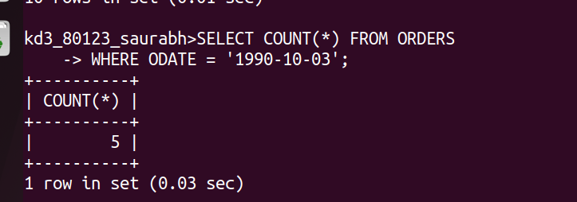
2

2) Write a query that counts the number of different non- null city values in the customers table

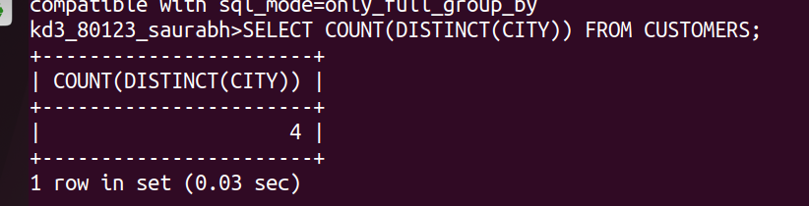
5

3) Write a query that selects each customer’ s smallest order.
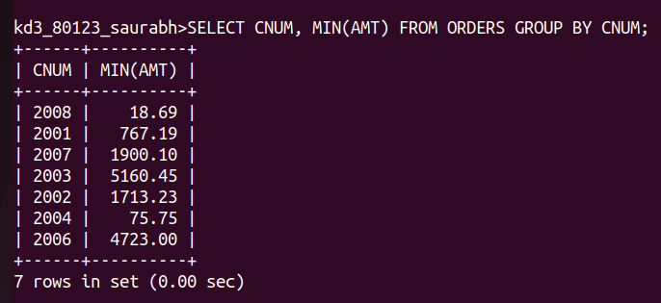

4) Write a Query that selects the first customer, in alphabetical order, whose name begins with G.

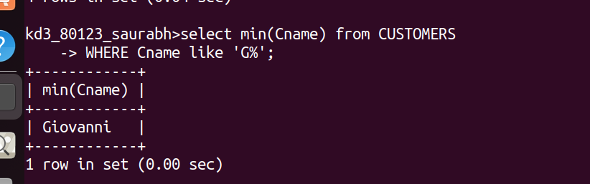

5)write a query that selects the highest rating in each city.
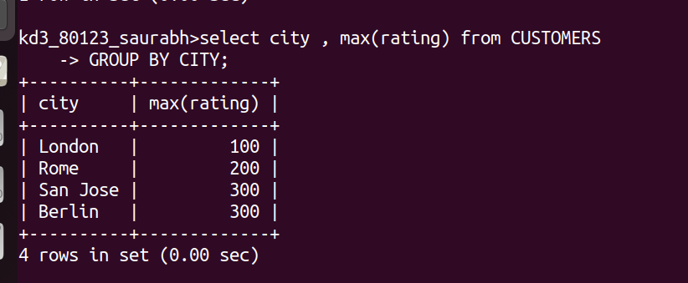

6) Write a query that counts the number of salespeople registering orders for each day.
